Gamechanger is an all-in-one tool that consolidates your team roster, game and practice schedule, parent communication, RSVPs, scorekeeping, and video streaming in a single app.

Getting Started
- Download the GameChanger App on Android Google Play or iOS App Store.
- Create a Gamechanger account or login with your existing account.
  - NOTE: For coaches, you should use the same email address on both Gamechanger and BRHLL.com

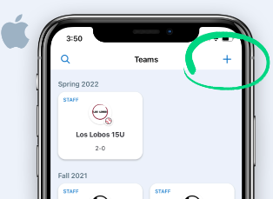  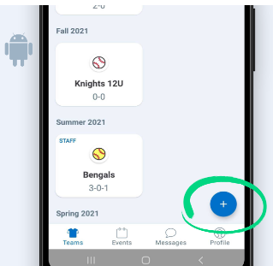 | Importing your Team  The free GameChanger app streamlines scheduling and parent communication into one easy-to-use app. It's easy to get started, and anyone can create a team!  - After logging in you will come to the Home screen with a list of all your teams historically.  - Tap the “ + “ button in upper right corner to create a new team.  - Select “Import SportsConnect” to import all of your team information to Gamechanger including Team Name, Coaches, Roster, and Parent Contacts.  - If not importing, you will need to select your sport, enter your city, and enter your team name information.  - BRHLL may send you an invitation to join a League or Organization so that all of a league’s teams can be grouped together.
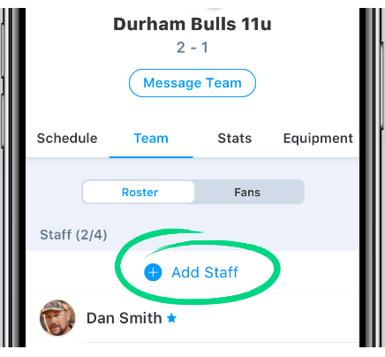 | Adding Staff Members  Staff Members are the people working behind the scenes to keep coaches, parents, and players on the same page all season long. On the GameChanger app, Staff Members can add/edit events, manage the team roster, update RSVP responses, stream video, score games, and access team stats.  - Teams can have up to 4 Team Staff Members. Staff Members typically include coaches, team managers, and team moms/dads.  - Tap the Home tab and tap the team your player is on.  - Tap on the Team tab.  - Tap on Add Staff  - Enter the email address of the staff member  - For more information on adding staff members, refer to https://teammanager.zendesk.com/hc/en-us/articles/115005457466-Adding-Removing-Staff-Members
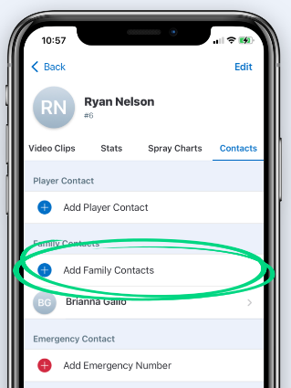 | Adding Family Members  Sharing is caring! GameChanger allows you to invite other members of your team community to follow along all season, in a few easy steps.  - Tap the Home tab and tap the team your player is on.  - Tap on the Team tab.  - Tap on the Player.  - Tap Contacts.  - Tap Add Family Contact for parents, grandparents, etc  - Type the family member's email address, or search your contacts for their email address.  - Tap Add.  - Existing users of GameChanger are automatically added as a Family contact of the player. New users will be invited to create a GameChanger account. After creating their account, they will automatically be linked to the team and player.  Inviting Fans  - While viewing your team, tap on the Team tab.  - Tap on the Fans tab to view a list of all the Fans currently on the team  - Tap on Invite Fans.  - Here, you have three ways to enter email addresses to invite fans to your team:  - Type in the email address manually.  - Copy and paste a list of email addresses.  - Search your contacts, and invite fans for whom you have an email address.  - Tap on Invite.  - For more information, refer to https://teammanager.zendesk.com/hc/en-us/articles/4402859033229-Inviting-Fans
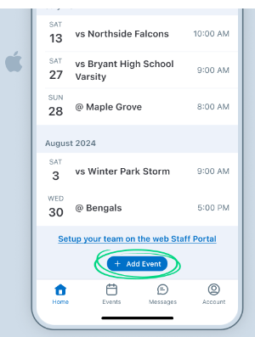  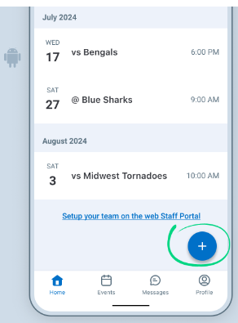 | Scheduling  Scheduling is a key feature of Gamechange. It allows coaches to create a practice and game schedule that parents can sync to their mobile calendars. It also allows your parents to RSVP their player’s attendance to practices and games helping you create a plan.  - Individual or repeating practices can be added at the coach’s discretion.  - BRHLL schedules can be imported at a later date once the schedule is released on BRHLL.com SportsConnect prior to opening day.  - Individual games can be added with an opponent, time, and location.  - Test out Scheduling  - While viewing your team, tap on the Team tab.  - Tap on the Schedule tab to view a list of upcoming events  - Tap on Add Event to add a practice  - Use 1349 E. 54th Street for School #55 Diamonds 1, 2, and 3.  - Use Crestview Ave & 46th St for Fairgrounds Diamonds 4, 5, 6 and the grassy practice area.  - For more information on Scheduling, refer to https://teammanager.zendesk.com/hc/en-us/articles/115005444163-Scheduling-Games-Practices-and-Team-Events
Team Messaging
GameChanger allows you to easily communicate to all parents and fans or individuals via a Messages forum.
- Test out Messages
  - Tap on the Messages on bottom of the screen
  - Find the team thread in which you want to communicate
  - Send a test message to the entire team
- For more information, refer to https://teammanager.zendesk.com/hc/en-us/articles/115005453983-Team-Messaging

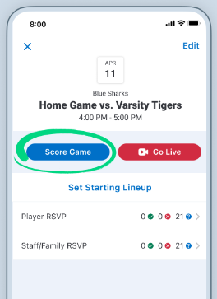  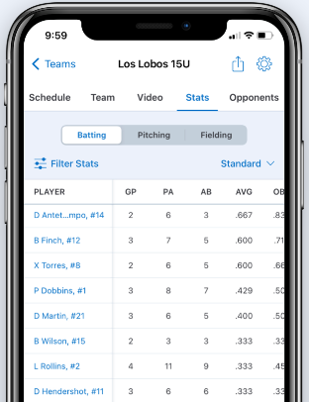 | Scorekeeping  Scorekeeping for games is recommended for all AAA and Majors levels games at BRHLL. It allows the team to maintain a book of record of the game, track pitch counts, keep player and team statistics and can easily be driven by one person with a mobile device during the game.  - Set your Staff  - Scorekeeping can only be done by a user that is added to the Team Staff. To add someone to the Staff, tap on the Team Tab, tap Team, tap Add Staff and enter the email address of the person you’d like to keep score.  - Practice scorekeeping!  - Scorekeeping is easy to do with a little practice. One can do so by even watching a baseball or softball game on tv.  - Tap on the Team tab.  - Tap the Settings widget in the upper right corner.  - Tap on Practice Scoring a Game.  - For more information, refer to https://teammanager.zendesk.com/hc/en-us/articles/360039839812-Scorekeeping-and-Stats  - The “organization” info will be submitted later to connect all the teams together.
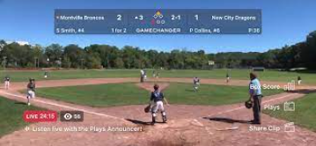  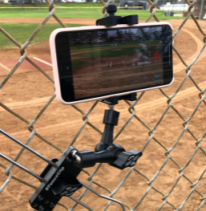 | Video Streaming  Gamechanger is able to live stream video of your games in order for remote family and fans to watch your team play.  - Streaming can be captured from any mobile device with Gamechanger installed including iPhone and Android.  - It can also be done from other devices such as GoPro, Mevo, etc connected to a mobile hotspot, mobile device tethering, or wifi.  - When streaming and scorekeeping at the same time, Gamechanger will save video highlights of plays throughout the game and save them to the player’s profile.  - For information on streaming gear, refer to https://gc.com/live-streaming-tools  - For more information on streaming instructions, refer to https://teammanager.zendesk.com/hc/en-us/sections/360011729352-Live-Video-Streaming

For step by step instructions for adding your team to Gamechanger you can also refer to an article at https://teammanager.zendesk.com/hc/en-us/articles/360006893592-Importing-Your-Team-From-Sports-Connect

For more information about roster management, scheduling, scorekeeping, and video streaming, please refer to the Gamechange Help Center at https://teammanager.zendesk.com/hc/en-us

A copy of this document is maintained at https://www.brhll.com/Default.aspx?tabid=1796649

